Database Concepts Experiment Guide

School of Computer Science

October 2020
History
Ver | Date | Author | Content
Ver 1.0 | 2016.09 | Ning Li | Create according to the Chinese Course
Ver 2.0 | 2017.11 | Xiaonan Zhao | Modify some inappropriate contents
Ver 3.0 | 2019.03 | Xiaonan Zhao | Add an optional experiment to Ex 2
Ver 4.0 | 2020.10 | Xiaonan Zhao | Modify for MySQL

Content
Content 3
1. Experiment Info 5
1.1. Experiment List 5
1.2. Experimental Environment 7
1.3. Experiment Grade 7
1.4. Experiment Requirement 7
2. Experimental Preparation 9
2.1. Construction of Experimental Environment 9
2.2. Experimental Environment Access 9
3. Experiment 1: Create and Manage Database and Table 12
3.1. Goal 12
3.2. Content 12
4. Experiment 2: Manipulate the Data in Table 19
4.1. Goal 19
4.2. Content 19
5. Experiment 3: Data Integrity and Security 25
5.1. Goal 25
5.2. Content 25
6. Experiment 4: View and Index 29
6.1. Goal 29
6.2. Content 29
7. Experiment 5: Trigger, Procedure and Function 33
7.1. Goal 33
7.2. Content 33
8. Experiment 6: ODBC/JDBC（optional） 37
8.1. Goal 37
8.2. Content 37
9. Experiment 7：Transaction 44
9.1. Goal 44
9.2. Content 44
10. Experiment 8：Project 45
10.1. Goal 45
10.2. Requirement 45
10.3. Content 45
11. Appendix 46

Experiment Info

Experiment List
Table 1 Experiment List
No | Content | Detailed Info | Type  （ratio） | Hours
1 | Create and manage database and table | Backup/Restore database , Create/Alter/Drop database and table | Verification  (5%) | 2
2 | Data Manipulation of base table | Query, Insert, Delete, Update  Optional： design query statement for TPC-H | Design and verification(10%) | 2
3 | Data integrity and security control | Data integrity and security | Design and verification(5%) | 2
4 | View and Index | Create/Drop view and index  Optional：DB maintain and manage manual | Design and verification(10%) | 2
5 | Trigger, storage procedure and function | Trigger, storage procedure and function  Optional：Bank DB operations practice | Design and Programming  (10%) | 2
6 | ODBC/JDBC programming | ODBC database programming  (JDBC is optional) | Programming  (10%) | 2
7 | Transaction and concurrency control | Transaction commit/rollback；isolation and lock, transaction log | verification(10%) | 2
8 | Project | Design and implement a database application system | Comprehension  (40%) | 2
 |  |  |  | 16

Note：The 8th experiment，that is to say project，students should focus on database design in 2 hours experiment class, and finish other works such as programming and testing with their extracurricular time. And also，students can f accomplish a larger project in group.

Experimental Environment
In this experiment, the server-side database instance of the cloud database GaussDB (for MySQL) have been purchased and prepared in advance, and a local MySQL server will be installed in the laboratory. The client can connect the DB sever in many ways, such as DAS (web version) client, local GUI (such as MySQL Workbench) or mysql command line client.
Remote server: GaussDB (for MySQL) [based on MySQL8.0]
Local server: MySQL8.0.*
Local client: browser, MySQL Workbench, Mysql command line client

Experiment Grade
The score of each experiment is 100, and we use the final weighted average grade as the final grade of this course.
Item | requirement | percent
attendance | Attend the course normally | 10%
peview | Report(no template, paper/electronic edition | 10%
experiment | The correctness of experiment processes and results | 60%
report | Correctly, clearly,completely | 20%
Total |  | 100%

Experiment Requirement
- Strictly abide by all disciplines of the laboratory.
- Preview before each experiment, and write a simple report (paper / electronic edition).
- Students should submit the electronic experimental report for each experiment. Experiment report file name should use such format: DBn_XXXXXX(StudentNo)_Name. For example, Li Hua’s student ID is 20181234, his report for the first lab class can be named as DB1_20181234_lihua.
- For each experiment, the student should submit an electronic edition of experiment report(A template will be provided) and the experiment source code. If the source code is included in the experiment report, it needn’t be submitted separately again, otherwise the source code and experiment report should be submitted as a compressed package. The experiment report should include the following contents: experiment content, experiment design, experiment steps, and running results (it can be the output of the program or the screenshot of the running screen. The screenshot should be as small as possible to limit the submitted file size)
- In the experiment report, the screenshot of all the important steps should be contained.
- Students should write down all the problems they have encountered during the experiment process, and describe how did they solve the problems.
- Save all your experiment materials and documents until the grade is published.

Experimental Preparation

Construction of Experimental Environment
The server-side environment of cloud database gaussdb (for MySQL) does not need to be built individually. If you want to know the process of purchasing and building database, please refer to the guide to building cloud database gaussdb (for MySQL) (Chinese edition only).
If you want to install MySQL 8.0 locally, you can download the installation package from the official website of MySQL and install it by yourself. Reference document: MySQL 8.0 installation and common mistakes.doc
https://dev.mysql.com/downloads/windows/installer/8.0.html

Experimental Environment Access
- Web accessing cloud DB GaussDB(for MySQL)
https://auth.huaweicloud.com/authui/login.html?locale=zh-cn&service=https%3A%2F%2Fwww.huaweicloud.com%2F#/login

- Lohin web page，choose【IAM用户登录】mode，as shown in the following figure。
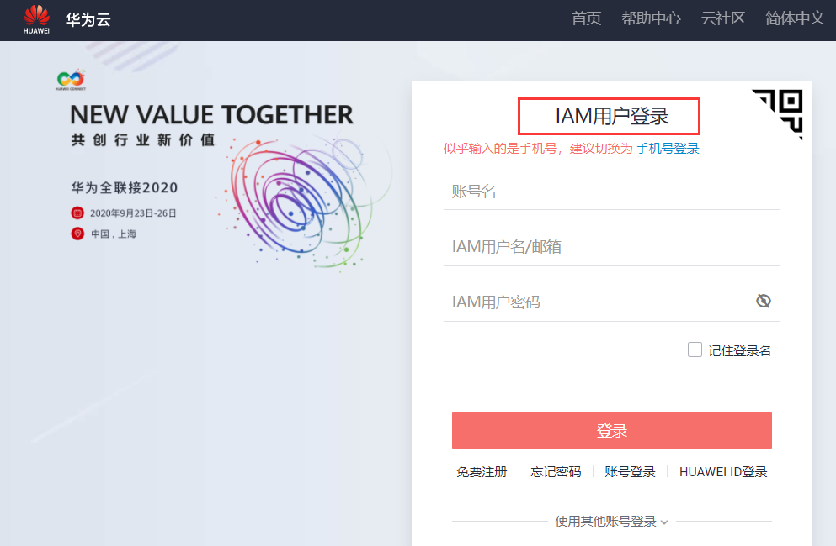
账号名：hw22222337
IAM用户名(username)： s+studentID，for example：s2018123456（a student）
t+instructorID/studentID,for example: t2020123456（teacher/teach assistant）
IAM用户密码(passwd)：GaussDB@123，（after login, password can be changed）
- After login normally，the webpage will be shown like following。click【控制台】to enter the console page.
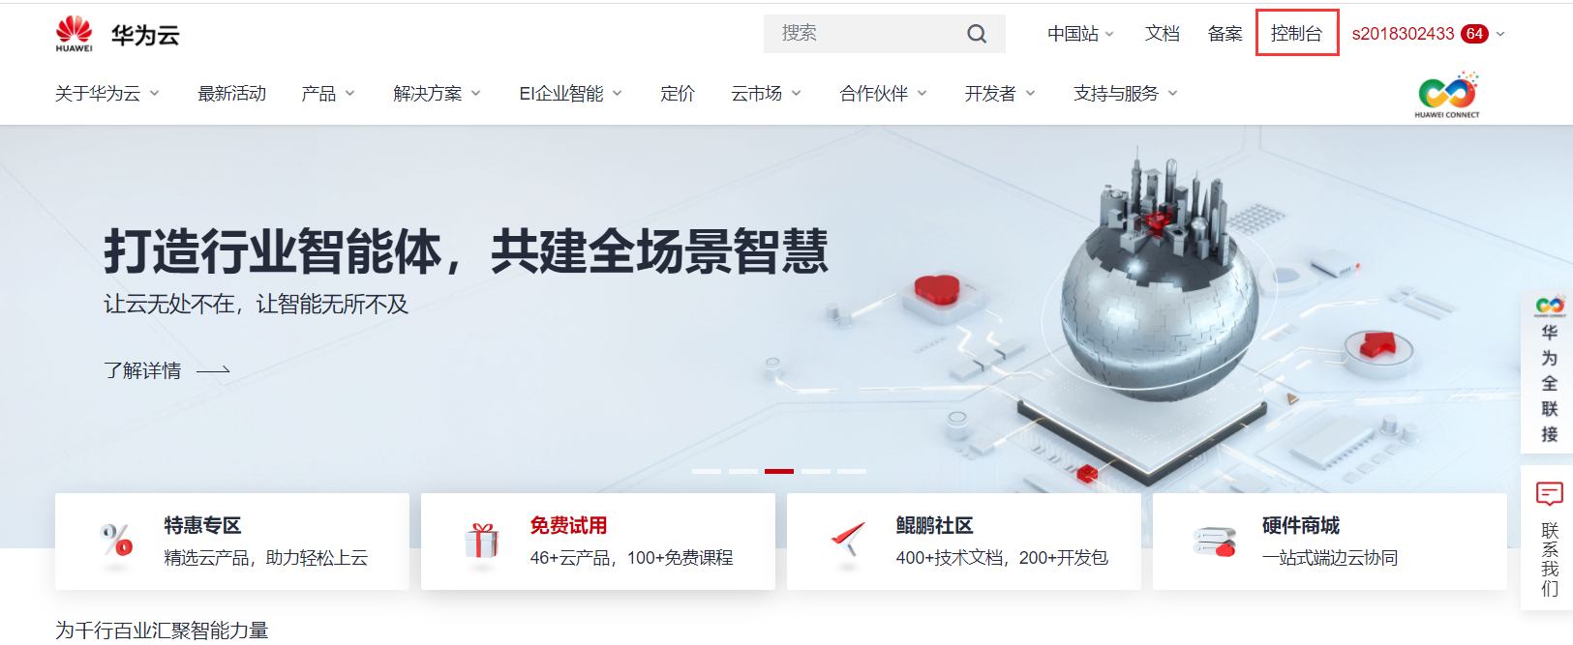

- In the page of console,choose tha tab of [云数据库GaussDB].
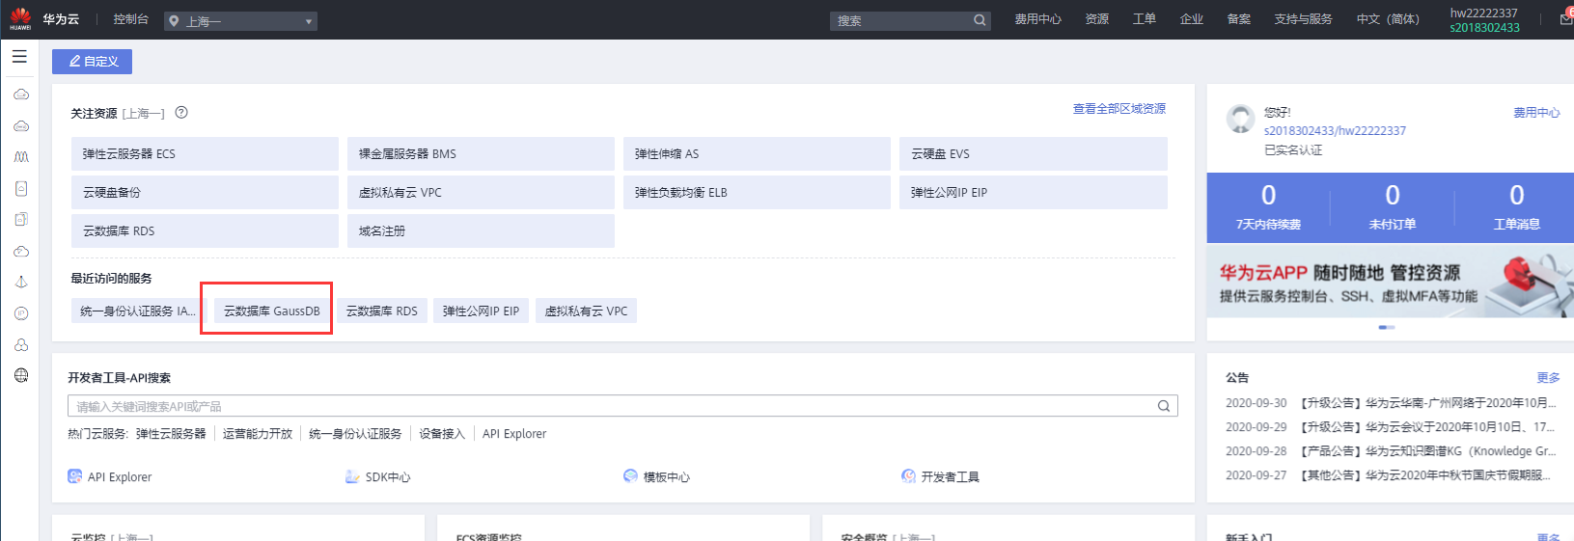

- Click:”云数据库GaussDB” in the browser，the running DB instance with the name “gauss-nwpu2020” will appear in the window as following figure shown.
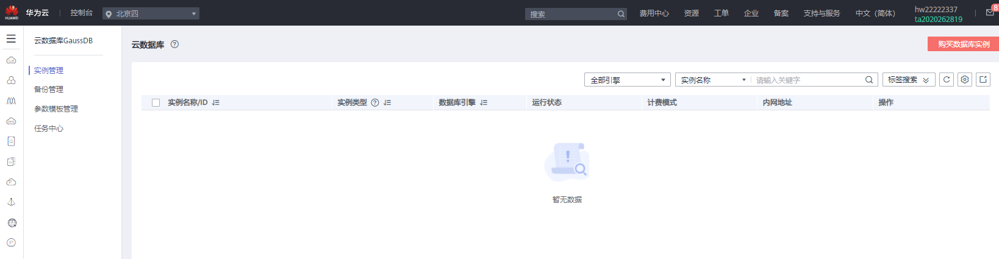

- Use MySQL Workbench or command line to access the remote DB instance。
Hostname: 139.9.119.34
（the purchased internet IP，if it is changed,we will notify in advance）
Username: same to the IAM username (s+studnetID)
Password: GaussDB@123

Experiment 1: Create and Manage Database and Table

Goal
- Familiar with command line and GUI connection method in MySQL.
- Master SQL statement to create database and table.
- Master the update and deletion methods of database and tables.
- Master the basic methods of backup and restore database.
- Understand the logical structure and physical structure of MySQL database.

Content
- Use GUI to connect the DBMS（10 points）。
Hint: try to use both web and MySQL Workbench methods.
- Use command line to connect the DBMS（10 points）.
- Create,backup,drop and restore database and tables through GUI.(40 points, each operation 5 points)
- Database and table
Database name：SPJ_MNG，four tables in the database：S, P, J, SPJ
S (SNO, SNAME, STATUS, CITY)
P (PNO, PNAME, COLOR, WEIGHT)
J (JNO, JNAME, CITY)
SPJ (SNO, PNO, JNO, QTY)
The supplier table S is composed of supplier code (SNO), supplier name (SNAME), supplier status (STATUS) and supplier city (CITY).
Part list P consists of part code (PNO), part name (PNAME), color (COLOR) and weight (WEIGHT).
Project table J consists of project code (JNO), project name (JNAME) and project city (CITY).
The supply situation table SPJ is composed of supplier code (SNO), part code (PNO), project code (JNO) and supply quantity (QTY). It indicates that the quantity of a certain part supplied by a supplier to an project is QTY.
Now there are several data in the database as follows. The specified operation is completed based on the database table.

Table S Table SPJ
SNO | SNAME | STATUS | CITY |  |  | SNO | PNO | JNO | QTY
S1 | JINGYI | 20 | Tianjin |  | 1 | S1 | P1 | J1 | 200
S2 | SHENGXI | 10 | Beijing |  | 2 | S1 | P1 | J3 | 100
S3 | DONGFANGHONG | 30 | Beijing |  | 3 | S1 | P1 | J4 | 700
S4 | FENGTAISHENG | 20 | Tianjin |  | 4 | S1 | P2 | J2 | 100
S5 | WEIMIN | 30 | Shanghai |  | 5 | S2 | P3 | J1 | 400
Table P |  |  |  |  | 6 | S2 | P3 | J2 | 200
PNO | PNAME | COLOR | WEIGHT |  | 7 | S2 | P3 | J4 | 500
P1 | nut | red | 12 |  | 8 | S2 | P3 | J5 | 400
P2 | bolt | green | 17 |  | 9 | S2 | P5 | J1 | 400
P3 | screwdriver | blue | 14 |  | 10 | S2 | P5 | J2 | 100
P4 | screwdriver | red | 14 |  | 11 | S3 | P1 | J1 | 200
P5 | cam | blue | 40 |  | 12 | S3 | P3 | J1 | 200
P6 | gear | red | 30 |  | 13 | S4 | P5 | J1 | 200
Table J |  |  |  |  | 14 | S4 | P6 | J3 | 100
JNO | JNAME | CITY |  |  | 15 | S4 | P6 | J4 | 300
J1 | SANJIAN | Beijing |  |  | 16 | S5 | P2 | J4 | 100
J2 | YIQI | Changchun |  |  | 17 | S5 | P3 | J1 | 200
J3 | Spring Factory | Tianjin |  |  | 18 | S5 | P6 | J2 | 200
J4 | shipyard | Tianjin |  |  | 19 | S5 | P6 | J4 | 500
J5 | Locomotives Factory | Xian
J6 | Radio Factory | Changzhou
J7 | Semiconductor Factory | Nanjing

    - Create database SPJ_MNG
Hint：right click【Create Schema】

    - Create four tables in database SPJ_MNG（add some tuples in each table)。
Hint：choose one created talble, right click and choose[select rows]，in the display results, there is a editable table, input some tuples directly.

    - Export the database SPJ_MNG as a *.SQLfile
Hint：in MySQL WorkBench upper left a navigation can be used，choose Administration → Data Export。Choose the target database, set some parameters and export it.

    - Delete the table of supplier(table SPJ)
Hint：【Drop Table】

    - Delete database SPJ_MNG
Hint：【Drop Schema】

    - Restore the database SPJ_MNG with the file you have backed up in step （3）
Hint：in MySQL WorkBench choose Administration → Data Import/Restore。Choose the database SPJ_MNG first，then choose all the the directory to import.

    - Update table S，Add an attribute of contact phone number STEL, the data type is string , and modify the maximum string length allowed by SNO in table S.

    - Understand the physical storage files of MySQL, and check the data files under the local MySQL service installation directory (such as the default installation directory: C: \programdata \ MySQL\ MySQL server 8.0\ data). Try to create tables according to different storage engines of InnoDB and MyISAM, observe and explain the differences of physical storage files.
Hint: you can query the data storage directory in MySQL:
show global variables like "%datadir%";

- Create,backup,drop and restore database and table using MySQL command line.(40 points, 5 points for each requirement)
- Database and tables
Datbase name: university
Tables:
(primary key: red color foreign key: )
Classroom:building, room_number,capacity
Department:dept_name, building, budget
Course:course_id,title,dept_name,credits
Instructor:ID,name,dept_name,salary
Section:course_id,sec_id,semester,year,building,room_number,time_slot_id
Teaches:ID,course_id,sec_id,semester,year
Student:ID,name,dept_name,tot_cred
Takes:ID,course_id,sec_id,semester,year,grade
Advisor:s_ID,i_ID (s_ID references student (ID), i_ID references instructor (ID))
Time_slot: time_slot_id,day,start_hr,start_min,end_hr,end_min
Prereq: course_id, prereq_id
Note: some hint for data type and domain
building:varchar(15), room_number: varchar(7), capacity:numeric(4,0)
name/dept_name:varchar(20), budget: numeric(12,2), course_id:varchar(8),
title:varchar(50), credits:numeric(2,0), ID:varchar(5), salary:numeric(8,2),
sec_id:varchar(8), semester:varchar(6),year:numeric(4,0),time_slot_id:varchar(4), tot_cred:numeric(3,0),grade: varchar(2), day:varchar(1),start_hr:numeric(2)
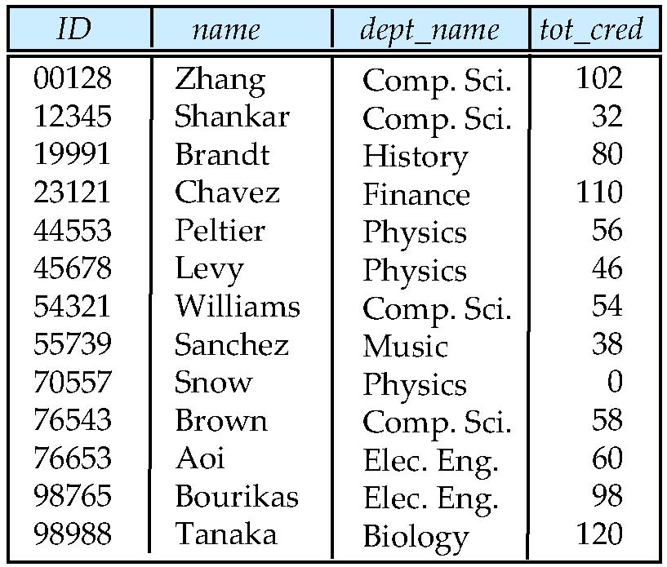
The student relation
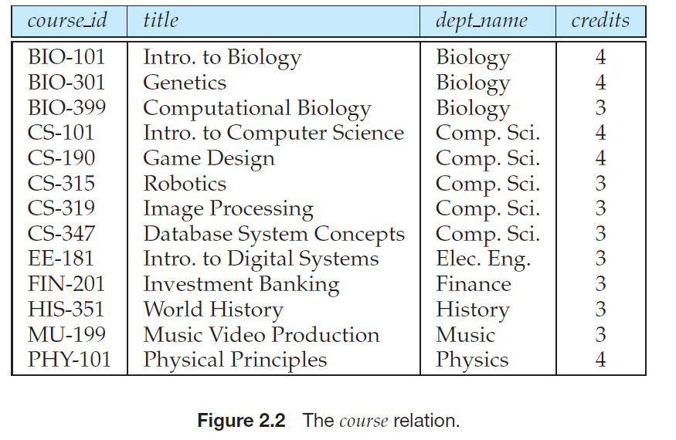
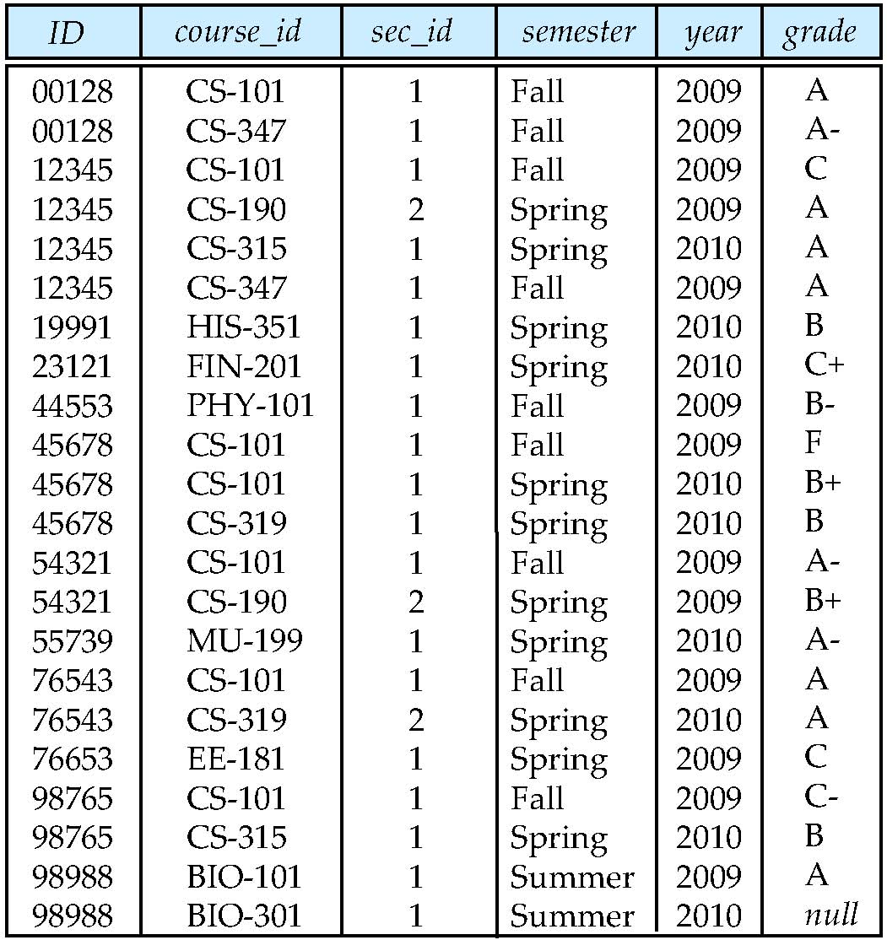
The takes relation
- Use SQL statements to create a database of university.
- Use SQL to create 3 tables:student, course, takes, define the data type and primary key, ignore the other constraints, add some tuples if you like.
- Backup the database of university.
Hint: in the command line window, swith to the directory C:\Program Files\MySQL\MySQL Server 8.0\bin(if the directory is already set in the environment variable, skip it), use the command of mysqldump.
mysqldump -h localhost -u root -p university> d:\university.sql
mysqldump -h localhost -u root -p --no-data --databases university> d:\s2.sql
-h: server name or IP；-u: username; -p：password university：database to be back up
--no-data: database not to be back up
Meaning of the command： backup the local database ‘university’ to the file ‘d:\university.sql’ 。
For more information of this command, refer to the url：https://dev.mysql.com/doc/refman/8.0/en/mysqldump.html
With command mysqldump, we can also export the database as txt or csv files.

- Delete created tables with SQL statement.
- Delete created database with SQL statement.
- Restore the database with the backed up files you’ve got in the operation of step (3).
Hint: first, use SQL statement to create university database, and then use the backup files in (3) to restore. open cmd.exe and run the program, switch to the bin directory of MySQL (if the environment variables have been configured, no switch), and use the following command to restore:
mysql -h localhost -u root -p university< d:\ university.sql
If you have a prepared data CSV file, you can also use the command of LOAD DATA to import the data.
- Use SQL statement to add a new column STEL to store phone number into the table of student, and modify the max length of the attribute ID.
- Check the SQL scripts that define the database or table in the SQL file generated by mysqldump, and compare the similarities and differences between the automatically generated scripts and the SQL statements written by yourself.

Experiment 2: Manipulate the Data in Table

Goal
1. Master all kinds of data operation about basic table in GUI.
2. Familiar with SQL statements for data insertion, modification and deletion of basic tables.
3. Master the SQL statement of data query.
4. Master the basic knowledge of SQL query performance analysis.
5. Understand TPC-H benchmark database.

Content
- Use SQL statement to insert all the tuples into the database SPJ_MNG and university which have been list in the previous experiment.
- Modificaion the data of tables with SQL statement.
- Modify one tuple in the table of student
- Delete one tuple from table of student.
- In the database of SPJ_MNG, use SQL statement to do the following update operations:
- Change the color of all red parts to blue.
- Part P6 supplied by S5 for J4 is replaced by S3, please make necessary modification.
- Delete S2 record from supplier table and delete corresponding record from supply table.
- Please insert (S2, J6, p4200) into the supply table SPJ.Finish the following queries about the database university with SQL statement.
- Use three different ways (SQL statement) to find the student ID and name of all students who take “Database System Concept”, and then analyze and compare the performance of each query process.
- For university database, complete the following data query with SQL statement
- Query the total score of credits obtained by each student , and output the student ID, name and credit obtained in the order from high to low.
- Query the name of the student: the student has taken all courses and one of the courses has a grade of better than B .
- Use at least three different SQL statements to query the university database: query the student ID and name of the course named "database", and then design the experiment by ourselves, compare and analyze the efficiency of the three kinds of query with data, and analyze the reasons.
Hint: in order to compare it more clearly, you’d better create a bigger table.
- （optional）TPC-H is one of the database benchmarks released by TPC international organization. The database simulates the data of a typical enterprise: parts, customers, parts, suppliers, products, orders and so on- ddl.sql Documents.Based on database TPC-H (database definition statements can be defined referring to the file “tcp-h-ddl.sql”), design the following queries and test the queries with some data：
- Single table query (to realize operations of projection and selection)
- Grouping stastistic query(using “group by”, without using “group by”)
- Single table query with self-join operation
- Multple table query with join operation
- Nested query with IN clause
- Nested query with EXISTS clause
- Neseted query with FROM clause
- Set query( intersect, union and except)
The TPC-H database is designed as following:（referring to the file tcp-ds-v2.17.3.docx）：
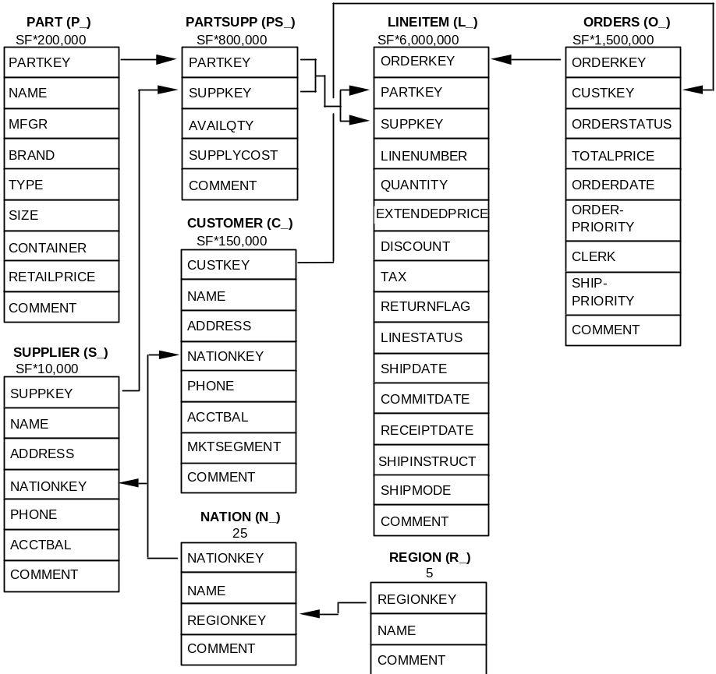
Discription：
- The database models a company which includes the information of :customers, products, supplier, orders, partsupp, etc.
- The numbes or SF(Scale factor)* numbers under each table are used to indicate the expected count of tuples of the table, the detailed information of tables are as following:
PART Table
Column Name | Datatype Requirements | Comment
P_PARTKEY | identifier | SF*200,000 are populated
P_NAME | variable text, size 55
P_MFGR | fixed text, size 25
P_BRAND | fixed text, size 10
P_TYPE | variable text, size 25
P_SIZE | integer
P_CONTAINER | fixed text, size 10
P_RETAILPRICE | decimal
P_COMMENT | variable text, size 23
Primary Key: P_PARTKEY
SUPPLIER Table
Column Name | Datatype Requirements | Comment
S_SUPPKEY | identifier | SF*10,000 are populated
S_NAME | fixed text, size 25
S_ADDRESS | variable text, size 40
S_NATIONKEY | Identifier | Foreign Key to N_NATIONKEY
S_PHONE | fixed text, size 15
S_ACCTBAL | decimal
S_COMMENT | variable text, size 101
Primary Key: S_SUPPKEY
PARTSUPP Table
Column Name | Datatype Requirements | Comment
PS_PARTKEY | Identifier | Foreign Key to P_PARTKEY
PS_SUPPKEY | Identifier | Foreign Key to S_SUPPKEY
PS_AVAILQTY | integer
PS_SUPPLYCOST | Decimal
PS_COMMENT | variable text, size 199
Primary Key: PS_PARTKEY, PS_SUPPKEY
CUSTOMER Table
Column Name | Datatype Requirements | Comment
C_CUSTKEY | Identifier | SF*150,000 are populated
C_NAME | variable text, size 25
C_ADDRESS | variable text, size 40
C_NATIONKEY | Identifier | Foreign Key to N_NATIONKEY
C_PHONE | fixed text, size 15
C_ACCTBAL | Decimal
C_MKTSEGMENT | fixed text, size 10
C_COMMENT | variable text, size 117
Primary Key: C_CUSTKEY
ORDERS Table
Column Name | Datatype Requirements | Comment
O_ORDERKEY | Identifier | SF*1,500,000 are sparsely populated
O_CUSTKEY | Identifier | Foreign Key to C_CUSTKEY
O_ORDERSTATUS | fixed text, size 1
O_TOTALPRICE | Decimal
O_ORDERDATE | Date
O_ORDERPRIORITY | fixed text, size 15
O_CLERK | fixed text, size 15
O_SHIPPRIORITY | Integer
O_COMMENT | variable text, size 79
Primary Key: O_ORDERKEY
LINEITEM Table
Column Name | Datatype Requirements | Comment
L_ORDERKEY | identifier | Foreign Key to O_ORDERKEY
L_PARTKEY | identifier | Foreign key to P_PARTKEY, first part of the compound Foreign Key to (PS_PARTKEY, PS_SUPPKEY) with L_SUPPKEY
L_SUPPKEY | Identifier | Foreign key to S_SUPPKEY, second part of the compound Foreign Key to (PS_PARTKEY, PS_SUPPKEY) with L_PARTKEY
L_LINENUMBER | integer
L_QUANTITY | decimal
L_EXTENDEDPRICE | decimal
L_DISCOUNT | decimal
L_TAX | decimal
L_RETURNFLAG | fixed text, size 1
L_LINESTATUS | fixed text, size 1
L_SHIPDATE | date
L_COMMITDATE | date
L_RECEIPTDATE | date
L_SHIPINSTRUCT | fixed text, size 25
L_SHIPMODE | fixed text, size 10
L_COMMENT | variable text size 44
Primary Key: L_ORDERKEY, L_LINENUMBER
NATION Table
Column Name | Datatype Requirements | Comment
N_NATIONKEY | identifier | 25 nations are populated
N_NAME | fixed text, size 25
N_REGIONKEY | identifier | Foreign Key to R_REGIONKEY
N_COMMENT | variable text, size 152
Primary Key: N_NATIONKEY
REGION Table
Column Name | Datatype Requirements | Comment
R_REGIONKEY | identifier | 5 regions are populated
R_NAME | fixed text, size 25
R_COMMENT | variable text, size 152
Primary Key: R_REGIONKEY

Experiment 3: Data Integrity and Security

Goal
- To practice how to define the data integrity.
- To practice how to create users
- To practice how to grant/revoke privileges of databases and tables.

Content
Database name：Student， including 3 tables：
S (SNO, SNAME, SGENDER, SBIRTH, SDEPT, SAGE)
C (CNO, CNAME, CPNO, CREDIT)
SC (SNO, CNO, GRADE)
Student information table S consists of student number (SNO), name (SNAME), gender (SGENDER), date of birth (SBIRTH), deparatment(SDEPT), age (SAGE).
Course information table C consists of course number (CNO), course name (CNAME), prerequisite course number (CPNO) and credit.
SC is composed of SNO, CNO and GRADE, it indicates that a student has taken a course with grade.
Table S Table SC
SNO | SNAME | SGENDER | SBIRTH | SDEPT |  | SNO | CNO | GRADE
2001 | Yong Li | male | 2000/01/01 | MA |  | 2001 | 1 | 92
2002 | Liu Chen | female | 2001/02/01 | IS |  | 2001 | 2 | 85
2003 | Wang Min | female | 1999/10/01 | CS |  | 2001 | 3 | 90
2004 | Zhang Li | male | 2001/06/01 | IS |  | 2002 | 2 | 78
 | Table C |  |  |  |  | 2002 | 3 | 84
CNO | CNAME | CPNO | CREDIT |  |  | 2003 | 6 | 91
1 | Database | 2 | 3
2 | Math |  | 5
3 | Information system | 1 | 2
4 | Operating system | 5 | 3
5 | Data structure | 6 | 3
6 | C languange |  | 2

- Add the following constraint and index with GUI(for university database)（10 points）.
    - Not null：add the not null constraint to S(SBITH).
    - Primary key：set the SNO as the primary key.
    - Unique constraint：add unique constraint for the primary key of SNAME, the constraint name is uk_Sname.
    - Default constraint：add the default value to S(SGENDER), the default value is “male”.

- Add forgein key constraints to table SC in the database Student with GUI, set SNO(foreign ke name is: sc_fk_sid) as a foreign key referencing table S, and set CNO as another foreign key referencing table C , name it with sc_fk_ cno. Try and validate different strategies in violation of the foreign key constraints :
NO Action/restrict/cascade/set to null（10 points）

- Drop the three tables in database Student, and create some tables through SQL statements with the following constraints.(10 points）
- Table S：same to the constraints set in question 1(1)。
- Table C：set CPNO as a foreign key，referencing table c itself with the attribute CNO.
- Table SC：set the foreign key constraints same to question2, and set the valid range of attribute GRADE with[0,100]. In addition, add one attribute ID to table SC, and set it as a primary key, and it can increase automaticlly. When a new tuple is inserted to the table, its(ID) value will increase by +1.

- Add or remove the following integrity constraints with SQL language. (10 points)
(1) Add constraint: SGENDER ’s value in table S can only be "male" or "female".
(2) Delete the SGENDER value constraint created in table S.
(3) Remove the foreign key constraints from the SC table.
(4) Add a new column TNAME (indicating the name of the student's tutor) in the student table S, and require that the tutor name must be all uppercase or lowercase letters, and the length cannot be less than 8 characters (Hint: You can use the Length() function and regular expression to CHECK your character string).

Try to finish the following requirements by connecting to the local database server

- Create and authorize new users in GUI. (20 points)
(1) Create two users who can access the current student database: Wang Ming and Li Yong.
(2) Complete the following authorizing:
① User Wang Ming has the priviliges to select and insert all tables.
② User Li Yong has the priviliges of select, insert, delete, update and create on the database.

2. Use SQL statement to authorize and withdraw permissions and verify permissions. (40 points)
Requirements: create relevant users and specified database tables, complete authorization and authority verification for each question, and then withdraw the authority and verify the authority.
(1) User Wang Ming has query privilege on two tables.
(2) User Li Yong has insert and delete privileges on the two tables.
(3) Each instructor only has the right to query his own record.
(4) User Liu Xing has query privilege on employee table and update privilige on salary field.
(5) User Zhang Xin has the right to modify the structure of the two tables.
(6) User Zhou Ping has all permissions on the two tables, and has the authority to authorize other users.
(7) User Yang Lan has the privilige to query the maximum wage, minimum wage and average wage from each department employee, but he cannot view the salary of each person.
Hint:
- Create user SQL statment: create user 'Wang Ming' @'localhost 'identified by' 123456 ';( in command line, ' is the quotation mark)
User name: Wang Ming @ localhost; password: 123456
- You can use the show grants for username （including the location: for example @localhost）to view the privileges list of each user.
- Create an appropriate view for some questions in this part.
- To view system current user: system function user ()

Experiment 4: View and Index

Goal
1. Be familiar with the use of GUI and SQL language to create, update and delete views.
2. Proficient in creating and deleting index using GUI and SQL language.
3. Understand and verify the role of index.

Content
- In the student database, use SQL statement to create a view of students who have taken the database course and are born in 2001. The view includes the information of student number, name, gender and grade. (5 points)
- Create a view for the supply situation of “SANJIAN”project, including the attributes of supplier code (SNO), part code (PNO) and supply quantity (QTY), with two ways with SQL statement.(view name:V_SPJ) (10 points)
- Complete the following view query with SQL statement. (10 points)
- Find out all the parts code and their quantity used by “SANJIAN” project
- Find out the supply situation of supplier S1.
- Update the data of views with SQL statement.(15 points)
    - Insert a tuple into the view V_SPJ.
Hint:
- In table SPJ,when JNO is permitted to be null, the tuple can be inserted into the actual table.Because of JN is NULL， the tuplewill not appears in the view.
- When the attribute JNO in table SPJ was set to be not null, you can use ‘instead of ’ trigger. MySQL does not support to create a trigger on a view, so in the MySQL environment, it is not necessary to answer this question.
    - Modify the quantity value of any tuple in the view V_SPJ.
    - Delete one tuple from the view V_SPJ
Hint: Only when the created view can be resoluted, it can be deleted normally, otherwise it will fail to be deleted.

- Create a descending index named IX_CNo for the CNO attribute of C table in student database by using GUI. (5 points)
- Use SQL statement to complete the following index operation on student database. (15 points)
(1) Create a non unique index named IX_CName on the CNAME attribute of table C.
(2) Create a composite index named IX_ngd_ NGD on the table S, which is an ascending index for sname, sgender and sdept attribute sets.
Hint: you can use show index from tablename to view the index information on the table.
(3) Delete index IX_ CNo of table C。
(4) Based on the above indexes (table C: primary key index of CNO, general index of CNAME; table S: primary key index of SnO, IX_ Nga composite index), use explain statement to obtain the query plan of each query statement, to observe the index usage in each query statement.
    - explain select * from c;
    - explain select * from c where cno = ‘1’;
    - explain select * from c where cname=’database’ ;
    - explain select * from c where cname like ‘%database%’;
    - explain select * from c where cname like ‘database%’;
    - explain select * from s where sname ='Zhangli' and sno='2001';
    - explain select * from s where sname ='Zhangli' and sgender='male' and sdept='IS';
    - explain select * from s where sname ='Zhangli' and sgender='male';
    - explain select * from s where sname ='Zhangli';
    - explain select * from s where sgender ='male';
    - explain select * from s where sgender ='male' and sdept='IS';

- Suppose there is a basic table userinfo as follows, design an experiment to verify the effect of index on database query efficiency. (40 points)
create table userinfo
(
user_id int primary key, //USER ID
username varchar(10), //USERNAME
gender char(1), //GENDER
age int, //AGE
c_id int //NO OF COLLEGE
)
(1) Verify the efficiency difference between indexed and non indexed queries.
(2) Verify the query efficiency of single field narrow index and multi field wide index, pay attention to understand the left most matching principle in wide index.
(3) Verify the difference of query efficiency between clustered index (primary key index) and secondary index: build clustered index and nonclustered index on the same field to compare query efficiency. (optional)
(4) At present, only memory engine of MySQL supports both b-tree index and hash index. Create a basic table based on memory storage engine in mysql, and verify the query efficiency difference between b-tree index and hash index based on this table. (optional)

Tips and requirements:
(1) Import a large amount of data (at least 100millio tuples) for validation.
(2) Use the explain command to analyze whether the SQL query uses the created index, and then analyze the performance reasons based on it.
(3) Generally, b-tree index is suitable for range query and hash index is suitable for point query.

Optional experiments
4. Refer to the " gaussdb (for MySQL) database maintenance and management manual.docx", and understand the following functions on the DAS side of Huawei cloud database:
(1) Section 1.2 manages the database cluster.
Special attention: this section of the experiment only to view the operation! Adding cluster nodes, changing cluster specifications, resetting administrator account name and password, cluster backup and recovery, parameter modification and other changes that have an impact on the global situation are only try to understand, not do the actual operations.
(2) 1.3.1 performance monitoring.
(3) 1.3.2 performance tuning.

Experiment 5: Trigger, Procedure and Function

Goal
To practice how to create the trigger/procedure/function.

Content
- For SPJ_ MNG database, create and execute the following procedures. (40 points)
- Create a stored procedure with no parameters named jsearch1. The function of the procedure is: when the procedure is executed, it returns all the information of Beijing suppliers in table S. Call the procedure and verify the results. (5 points)
- Create a procedure with input parameters named jsearch2. The function of the procedure is: when you enter the city name of a supplier (such as Beijing), it will return all the information of the specific supplier. Call the procedure and verify the results. (5 points)
- Create a procedure (or a function) jsearch3 with input and output parameters. The function of this procedure/funciton is: when a supplier number (input parameter SNO) is entered, the name of the supplier (output parameter SNAME) will be returned. Call the procedure/function and verify the results. (5 points)
- create a procedure jsearch4 using cursors, call the procedure and verify the result after . The function of the procedure is: when a project number JNO is input, the names (SNAMEs) of all suppliers supplying the engineering parts will be returned. These supplier names are spliced into a string and separated by comma ','.
For example: input: J2, output: ‘JINGYI, SHENGXIN, WEIMIN'. (10 points)
- View the text information of the procedures jsearch1 and jsearch2. (5 points)
Hint:use the command‘show create procedure jsearch1’. For convenience of viewing, you can add \G at the end of the above command and display it in the form of two columns of text.
- View the basic status information of the procedures jsearch1 and jsearch2. (5 points)
Hint: Show procedure status like 'jsearch%';
- Delete the procedure jsearch1. (5 points)

- Create and execute the following triggers for student database: (40 points in total)
- Delete the foreign key constraint on the SC table and create INSERT trigger named insert_s for the table SC. The function of the trigger is: when the user inserts a record into the SC table, if the inserted CNO value is not the existing value of CNO in table C, the user will be prompted a message "the data not in table C cannot be inserted" and the insertion of the data will be prevented; if the inserted SNO value is not an existing value of SNO in table S, the user will be prompted that "the data not in table S cannot be inserted" and the insertion of the data will be prevented. After the trigger created successfully, insert some records into the SC table to verify whether the trigger works normally. (5 points)
- Create a DELETE trigger named dele _ s1 for table S. The function of the trigger is: to prompt the user a message of "the data in this table cannot be deleted" and prevent the user from deleting the data in table S. After the trigger is created successfully, delete some record in table S to verify whether the trigger works normally. (5 points)
- Create a DELETE trigger named dele _ s2 for the table S, the function of the trigger is to delete the his course selection record in SC table when deleting a student’s record in S table. After the trigger is created successfully, delete some records in the table S and verify whether the trigger works normally (confirm whether the relevant data of S table and SC table are both deleted). (5 points)
- Create an UPDATE trigger for table S named update_s, the function of this trigger is to prohibit updating the contents of the column "sdept" in table S (make the updating be failed and prompt a message of "the column of ‘sdept’ cannot be updated). After the trigger is created successfully , update the content of the "sdept" column in the table S to verify whether the trigger works normally. (5 points)
- Delete update_s trigger. (5 points)
- Design a before update trigger and after update trigger, and compare the difference between the two triggers. (5 points)
- Create a new curriculum score statisticstable CAVGGRADE (CNO, snum, examsnum, avggrade), for the columns are indicating the course number, the number of students who choose the course, the number of students taking the exam, and the average score of the course respectively. Use a trigger to achieve the following functions: when insert, delete or update a person's score of SC table, automatically update the records in table CAVGGRADE correspondingly. Note that if the grade of a student in SC table is NULL, it indicates that the student has not taken the exam, and it is not necessary to calculate the average score. However, when grade is 0, that is, the score of the student is 0, theaverage grade needs to be calculated. (10 points)
Hint: in mysql, you need to create three triggers for insert, update and delete actions. You can first design and implement a common procedure, and then call the stored procedure in the 3 triggers.

- Create an table employee (EID, ename, salary) for the employees, assuming there are 1000 employee data in the table, complete the following requirements. (total 20 points, 10 points for each question)
- In order to automatically generate 1000 employee data, a user-defined function GENERATEEID is created to automatically generate employee ID. The employee ID is required to be an 8-digit number. The higher four digits indicate the current year in which the employee data is inserted, and the last four digits increase in the order from 0001 to 9999. For example, the first record inserted in the year of 2015 is 20150001, and all 1000 employee IDs are 20150001-20151000. Call this function to insert 1000 pieces of data automatically. (Note:when inserting data that the employee name can be any value , and the value of salary is between 2000 and 5000)
- The company plans to increase the salary of each employee according to certain rules. Please use cursor to create a procedure and execute the procedure to complete the salary adjustment. The salary increase rules are as follows:
- The salary below 3000 yuan, with a monthly increase of 300 yuan;
- The salary between 3000-4000 yuan, with a monthly increase of 200 yuan;
- The salary more than or equal to 4000 yuan, with a monthly increase of 50 yuan;

Experiment 6: ODBC/JDBC（optional）

Goal
To practice how to access the database from application with ODBC/JDBC or other methods.

Content
- ODBC data source configuration and program debugging. (20 points)
- To configure an ODBC data source, the data source name is: student, which contains the S table (student information table).
Hint: when configuring ODBC data source, you need to pay special attention to whether it is 32-bit or 64 bit. The configuration information should be consistent with the 32 / 64 bit of the application.
- To understand ODBC programming, read and run the program example (MFC or CSharp code) given in the experiment, it is required to write your own understanding of the program, or draw a flow chart of the program, and give the screenshot of the program running results.
Hint: the example program is implemented by MFC or CSharp language, and can run normally under vs2019. You can also use your favorite programming language or other IDE to re implement, but the function must be the same as the given example program.
- Refer to the above ODBC example program, use ODBC programming technology, write a simple program, including the database SPJ_ MNG connection, query, insert, modify and delete. (30 points)
- Comprehensive application experiment of bank finance. (50 points)
- According to the requirements, write SQL statements of different scenarios for the bank database.
- Referring to the programming examples of JDBC / ODBC / third-party library, we use one of the ways to access the bank database from the application program, and execute the SQL statement of question (1).
The scenario description of specific banks is as follows:
Suppose that there are five basic entities for the business of Bank C: customers, bank cards, financial products, insurance and funds. For these entities, it is assumed that bank C has the following businesses:
A customer can apply for multiple bank cards.
A customer can purchase multiple financial products, and each type of financial product can be purchased by multiple customers.
A customer can purchase multiple funds, and the same type of fund can be purchased by multiple customers.
A customer can purchase multiple insurance, and the same type of insurance can be purchased by multiple customers
According to the business relationship of Bank C, the following ER diagram is obtained.

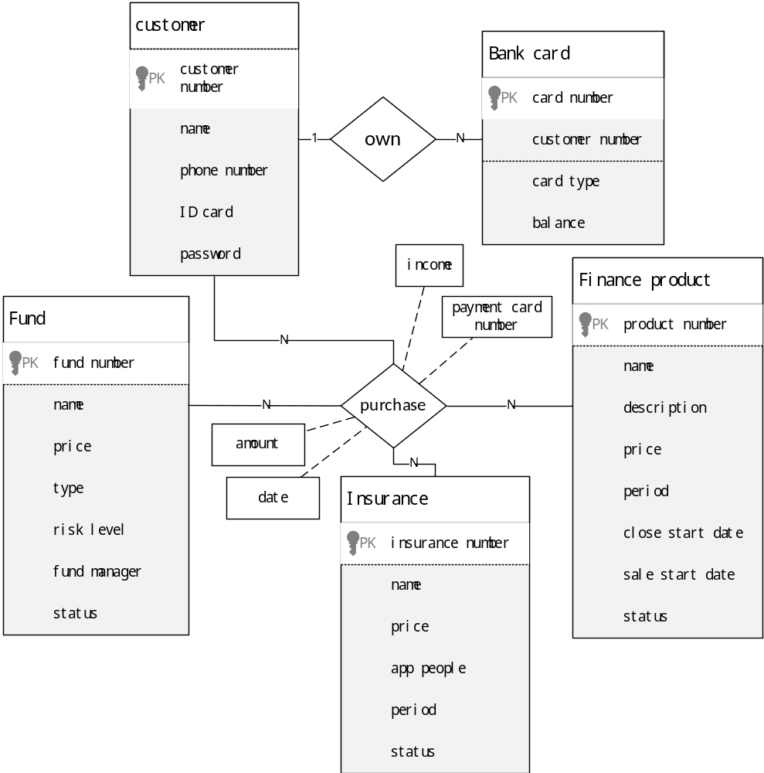
图 8-1 ER diagram of C Bbank System Finance

- A complete description of the five entities in Bank C is as follows:
Customer: customer number, customer name, customer ID, customer phone number, customer login password
Bank card: bank card number, bank card type, customer number, balance
Financial products: product name, product number, product status, product price, time period, close start date, sale start date, product discription
Insurance: Insurance name, insurance number, insurance price, applicable population, insurance period, product status
Fund: fund name, fund number, fund type, fund price, risk level, fund manager, fund status
- The tables of all entities in the database finance are as follows:
Customer table: customer (C_ ID，C_ NAME，C_ ID_ CARD，C_ PHONE，C_ PASSWORD）
Card table: Bank_ card（B_ NUMBER，B_ TYPE，B_ C_ ID, B_ BALANCE）
Financial products table:finances_ product（P_ NAME，P_ ID，P_ DESCRIPTION，P_ PRICE，P_CLOSE_DATE, P_SALE_DATE, P_STATUS, P_ YEAR）
Insurance table:insurance( I_ NAME，I_ ID，I_ PRICE，I_ PERSON，I_ YEAR，I_ STATUS）
Fund table: fund (F_ NAME，F_ ID，F_ TYPE，F_ PRICE，RISK_ LEVEL，F_ MANAGER, F_STATUS）
- The purchase relationships between different entities in Bank C are described as follows:
Financial products purchase table: customer number, financial product number, purchase time,purchase quantity, cumulative income, payment bank card number
Insurance purchase table: customer number, insurance number, insurance time, purchase quantity, cumulative income, payment bank card number
Fund purchase table: customer number, fund number, time of fund purchase, purchase quantity, cumulative income, payment bank card number

- The corresponding table of purchase relationships in database finance are as follows:
Financial products purchase table: C_finances(c_ ID, P_ ID, P_ TIME, P_ AMOUNT, P_ INCOME, B_ C_ ID)
Insurance purchase table: C_ insurance (C_ ID, I_ ID, I_ TIME, I_ AMOUNT, I_ INCOME, B_ C_ ID )
Fund purchase table: C_ fund (C_ ID, F_ ID, F_ TIME, F_ AMOUNT, F_ INCOME , B_ C_ ID)
Based on the DDL file of the database and the prepared data, complete the following functions:
- A new customer, whose ID number is "610103123456781234", registers at bank C , and applys for a new debit card. Please insert the record of the customer in the customer table and the card table.
- Add table constraints according to the business needs, and verify them after the constraints are added successfully.
- In the bank card table, financial product purchase table, insurance purchase table and fund purchase table, add the correct foreign key constraints: that is, the customer number is set as a foreign key, and references the customer number in the customer table, and the financial product number, insurance number and fund number refer to the corresponding table respectively.
- In the above basic tables, there are six attributes related to amount or price. In the real life, the amount or price will not be negative. Therefore, for these properties, add constraints whose value is greater than 0.
- Simulate the following business to write SQL statements for query:
- Query the card number and type information of all bank cards of bank C.
- Query the number of customers owned by bank C.
- query the customer number, name and ID number information of the bank cards owners.
- Statistics the amount of debit cards and credit cards respectively in all the bank cards.
- Query the average insurance price in the insurance table.
- Query the insurance type and price corresponding to the maximum and minimum of insurance price in the insurance table.
- Query the customer number and name whose bank card number is' 62220213020200006 '.
- Query the insurance name and applicable population whose insurance price is greater than the average value in the insurance product.
- Query the total number of financial products released by Bank C, by using the P_ YEAR to group.
- Query the insurance number, insurance name and insurance period applicable to the elderly people.
- Create a business view based on the following queries:
- Create a view containing customer number, name and ID number of all the customers who have at least one bank card.
- Modify view: on the basis of the original view, only the customers with credit cards are included.
- Simulate the business changes, people's demand for fund query has increased significantly. Create a composite index on the fund purchase table:
C_ id ASC, f_ id ASC, f_ amount DESC
- Simulate the business demands, add, delete and modify data:
- A customer with customer number 2, applys to update his phone numbers with '13312345678'.
- Simulate the simplified process of the sale, purchase, settlement and stop saling of No. 4 financial product.

- Step 1:The bank sells new financial product.
On December 1, 2018, the bank will sell one-year financial product, No. 4, starting closing time is 2019 / 1 / 6, price is 8.0 yuan per share, status of 0 (0 means normal).
Hint: it is required to insert the appropriate record into table finances_product.

- Step 2:Customers purchase No. 4 financial products (purchase and deduct money from corresponding bank card).
Suppose there are three deals:
a. At 13:00:00:00 on January 5, 2019: customer 3 purchased 1000 shares of No. 4 financial product with bank card '62220213020000002':
b. At 14:00:00:00 on January 5, 2019: customer 5 purchased 1000 shares of No. 4 financial product with bank card '62222021302020200003'
c. 2015 / 1 / 5 15:00:00: customer 5 purchased 500 shares of financial product No.4 with bank card '62220213020000003'
Hint: you need to give insert some appropriate purchase records into the table C_finances, and the total purchase amount is calculated according to the purchase amount and price(unit price), and the corresponding amount is deducted from the purchased bank card. Pay attention to consider the occasion of insufficient balance of debit card, which may lead to purchase failure. The whole process involves multiple tables, so you can consider using procedures to encapsulate the whole process. In addition, the balance of the bank card should be updated， if the balance of the debit card is insufficien, the update would be failed.

- Step 3: The bank cashes the income
Assuming that the financial product expired on January 6, 2020, the income is assumed to be 5%. On January 6, 2020, the bank will cash in the proceeds for all users who purchase No. 4 financial product: calculate the income of all customers who purchased the product, and add the total amount of principal + income to the bank card balance.
Hint: according to the specified rate of income, calculate the balance (income + principal) of each purchase transaction of No. 4 financial product. The balance of the transaction is then added to the balance of the payment card of the transaction.

- Step 4: The bank stops the financial product No.4
It is assumed that the bank has finished processing the income cashing of financial product No.4. Now the bank wants to take the financial product off the shelf. Note that the foreign key constraints should be considered when deleting the financial product record.
Hint: you’d better backup the data before delete. For example, save the historical purchase records of No. 4 financial product to a separate history table, and then delete the relevant data of No.4 financial product from table C_ finances. When delete No.4 financial product from table finances_product, the foreign key constraint should be considered, and the purchase record of product 4 should be deleted first. We can also consider adding a column to finances_ product, to make the product property be invalid instead of deleting it completely.

- Use JDBC, ODBC or other third-party library programming to implement the connection to the finance database, and implement the function of step 2 and step 3 in question (6) above.

Experiment 7：Transaction

Goal
To practice the
- To grasp the concept transaction, and how to create the transaction.
- Understand the data problems in concurrency operation, and can repeat the four kinds of problems.

Content
Suppose our university permits the student to bind bank card and campus card, and create two new tables into database Student.
icbc_card(studcardid,icbcid,balance) //campus card ID, bank card ID，bank card balance
campus_card(studcardid,balance) //campus card ID，campus card balance

Finish the following assignment：
- Write a transaction process(begin tran) to finish the function: transfer 200 RMB from some student’s(whose student no is 20150032) campus card to his bank card. If some errors, it will rollback.
- Use four examples to present the four kinds of data inconsistent problems: update lost, dirty read unrepeatable read, phantom read.
- Use sp_lock to check the status of the current lock in system.
- Use command “dbcc log” to check some database’s log.

Experiment 8：Project

Goal
The goal of this project is to provide a realistic experience in the conceptual design, logical design, implementation, operation, and maintenance of a relational database and associated applications.

Requirement
- Steps
    - Requirement Analysis
    - E-R diagram
    - Relation Model
    - Design and implement the databases application system with your familiar programming languages.

- Submit：
    - The completed experiment report about this project, including develop tools and environment, important sources.
    - Source code and execution files.
    - The database backup.
    - Configuration document, and
    - Other：Helo, video(opitional ).

Content
You can select one of the following system to implement.
- Library Management System
- Student Information Management System
- Ticket Management System
- Hotel Information Management System
- Other (Your interested information management system)

Appendix

